AI-Powered Honeypot Threat Intelligence Platform
Contents
Project Checklist 2
Setting up Honeypot on Kali 4

Project Checklist
Phase | Task | Status | Notes
Phase 1: Lab Infrastructure | Design & document the virtual network architecture. |  | Plan the IP ranges and how VMs will communicate.
 | Create & configure the Windows Server 2019 VM (AD, DNS). |  | Promote to Domain Controller.
 | Create & configure Windows 10 VM and join it to the domain. |  | Ensure network connectivity between all VMs.
 | Create & configure the Kali Linux VM (base installation). | Completed | Updated system and installed basic tools.
Phase 2: Honeypot Setup | Install & configure the Cowrie honeypot on Kali Linux. | Completed | Documented and setup the honeypot on Kali
 | Test honeypot functionality by connecting from Windows 10 VM. |  | Verify that sessions and commands are being logged.
 | Harden the Kali VM (firewall, non-default credentials). |  | Ensure the honeypot itself is secure.
Phase 3: Data Pipeline | Design the SQLite database schema for logs & results. |  | Tables for: raw_logs, sessions, attacks, etc.
 | Develop Python script to parse Cowrie JSON logs. |  | Extract key fields like IP, username, commands, session ID.
 | Develop Python script for feature engineering. |  | Create features like login_fail_count, unique_commands, etc.
 | Automate the log ingestion process (e.g., cron job). |  | Script should run periodically to update the database.
Phase 4: AI/ML Engine | Collect initial dataset by simulating various attacks. |  | Run brute-force, simple commands, etc., from Win10 VM.
 | Perform Exploratory Data Analysis (EDA) on the dataset. |  | Understand patterns, distributions, and correlations.
 | Finalize feature set and prepare data for model training. |  | Data cleaning, normalization, and splitting.
 | Train and evaluate multiple ML models (e.g., Random Forest). |  | Compare accuracy, precision, recall.
 | Select the final model, tune hyperparameters, and export it (pickle). |  | Integrate the saved model into the main application.
Phase 5: Flask Dashboard | Setup Flask application structure and environment. |  | Create routes, templates, and static folders.
 | Develop core application routes (index, data API). |  | Connect Flask to the SQLite database.
 | Create dashboard HTML templates with CSS styling. |  | Focus on a clean, professional layout.
 | Integrate Chart.js for data visualizations (charts, graphs). |  | Create endpoints that serve data in JSON format for charts.
 | Integrate the ML model into a Flask route for real-time analysis. |  | New logs should be classified as they are processed.
Phase 6: Testing & Finale | Execute end-to-end testing with simulated attacks. |  | Ensure data flows from honeypot to dashboard correctly.
 | Validate ML model predictions on the dashboard. |  | Confirm classifications and scores are displayed accurately.
 | Finalize project documentation and code comments. |  | Prepare for presentation.
 | Create the final project presentation. |  | Showcase the workflow and results.

Setting up Honeypot on Kali
- Install system dependencies
  - sudo apt-get install git python3-pip python3-venv libssl-dev libffi-dev build-essential libpython3-dev python3-minimal authbind
- Create a user account
  - It’s strongly recommended to run with a dedicated non-root user id.
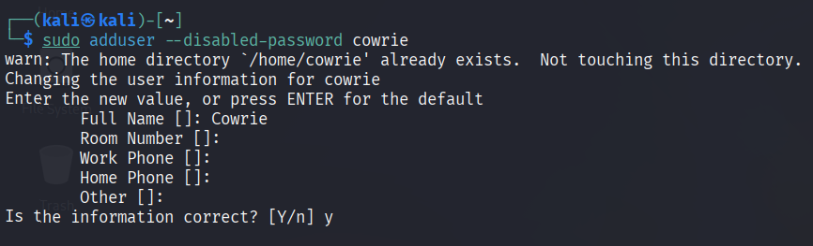
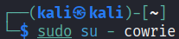
- Checkout the code
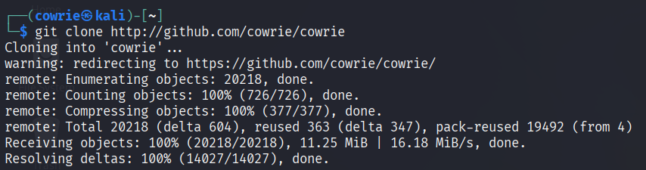
- Setup virtual environment
  - Create the virtual environment
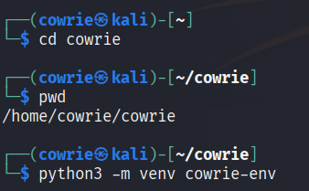
  - Activate the virtual environment and install packages
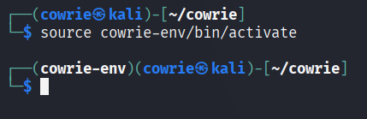
- Install configuration file
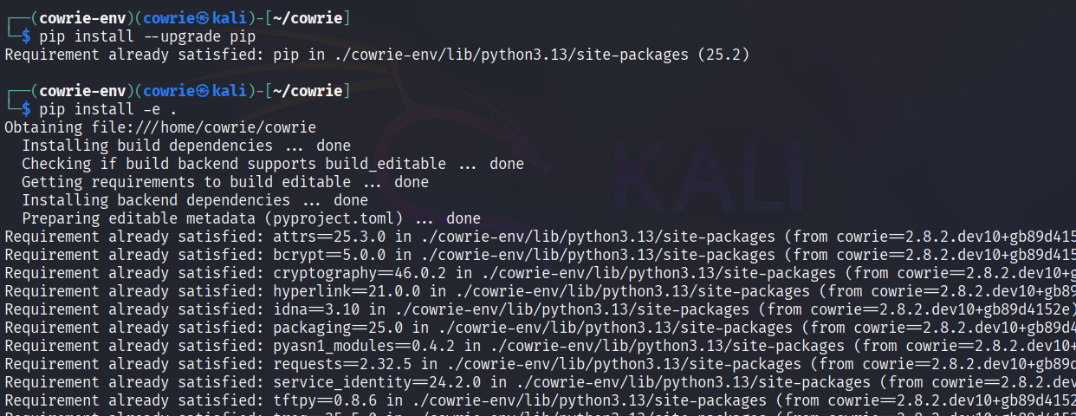
  - pip install --upgrade pip
Updates pip inside that virtual environment. Keeps it current.
  - pip install -e .
This installs Cowrie itself in “editable” mode, meaning it links directly to the source code you cloned, so changes to the code will reflect immediately.
The . just means “install what’s in the current folder.”
- Starting Cowrie
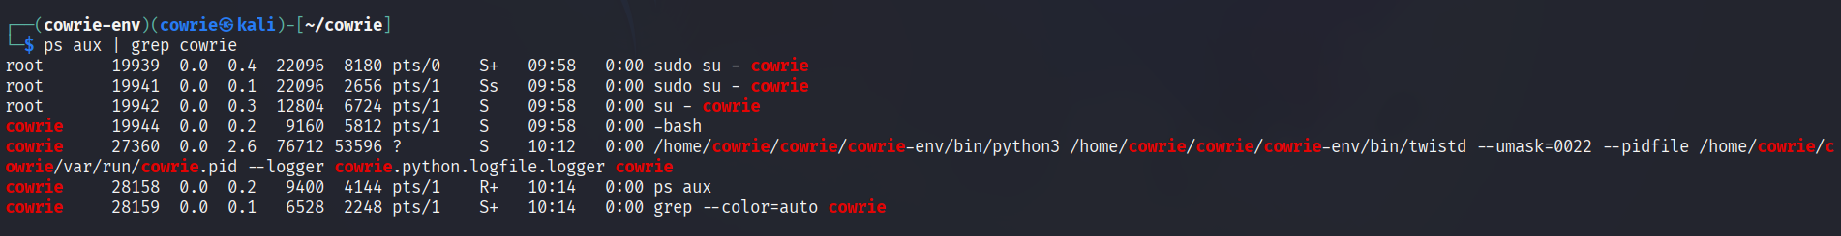
- Updating Cowrie
  - (cowrie-env) $ cowrie stop
  - (cowrie-env) $ git pull
  - (cowrie-env) $ python -m pip install --upgrade -e .
- SSH to the Honeypot
  - ssh -p 2222 root@machine-address
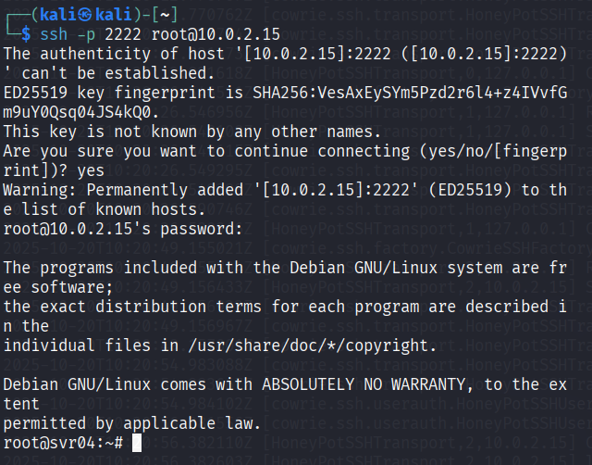
  - The logs are stored at var/log/cowrie

